# Nebraska Internship Consortium in Professional Psychology

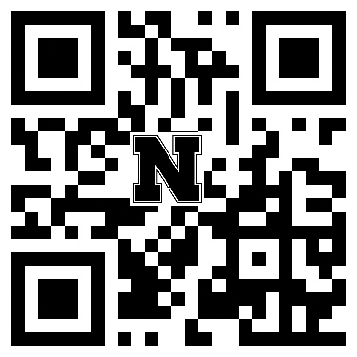

The Nebraska Internship Consortium in Professional Psychology (NICPP) is comprised of outpatient, inpatient, and university agencies in both rural and urban settings in Nebraska.

Its mission is to provide integrated, individually tailored and coordinated learning experiences that provide interns with opportunities to: (a) practice and expand on previously held knowledge and learned skills, (b) develop new skills and knowledge, and (c) experience professional growth and development, thus contributing to

the emergence of competent, ethical, scientist- practitioner professional psychologists. Each year, approximately 40 interns complete an APA accredited internship at one of the NICPP

member sites. Interns are supervised by licensed psychologists, receive ongoing feedback on

their mastery of core professional competencies, and select and work towards individualized professional goals. All interns participate in NICPP monthly seminars for broadened peer interactions, to present and receive peer feedback on their cases, to facilitate diversity training, and to receive didactic training in a broad array of topics in professional psychology. Interns take advantage of the consortium’s multiple agencies by completing structured instructional visits to each others’ sites within NICPP.

For more information:

**Kellan Willet** | Assistant Program Manager

*Department of Educational Psychology*

NICPP 41 Teachers College Hall Lincoln NE 68588-0345

402-472-1152

[kwillet3@unl.edu](mailto:kwillet3@unl.edu)

cehs.unl.edu/nicpp

This internship site agrees to abide by the APPIC policy that no person at this training facility will solicit,

accept, or use any ranking-related information from any intern applicant.

[**Scan to learn more about the NICPP or visit: cehs.unl.edu/nicpp**](http://cehs.unl.edu/nicpp)

Address questions regarding APA accreditation to:

**American Psychological Association Office of Program Consultation and Accreditation**

750 First St NE

Washington DC 20002-4242

202-336-5979

Our consortium is strongly committed to advancing diversity in the recruitment and retention of professional staff and interns. We seek to promote a safe and inclusive work environment to allow for reasonable

accommodation. Multicultural and diversity considerations are integrated into our monthly consortium days, clinical training, and supervision.

UNL docs not discriminate based on race, ethnicity, color, national origin, sex, religion, disability, age, sexual orientation, gender identity, genetic information, veteran status, marital status, and/or political affiliation in its programs, activities, or employment. ©2022. PL2205.

Nebraska Internship

Consortium in Professional Psychology

**Co-Training Director**

Beth Doll, Ph.D.

*University of Nebraska-Lincoln | Lincoln, NE*

Allison Grennan, Ph.D.

*Munroe-Meyer Institute | Omaha, NE*

**Associate Training Directors**

Natalie Jensen, Ph.D.

*Boys Town | Omaha, NE*

# Boys Town

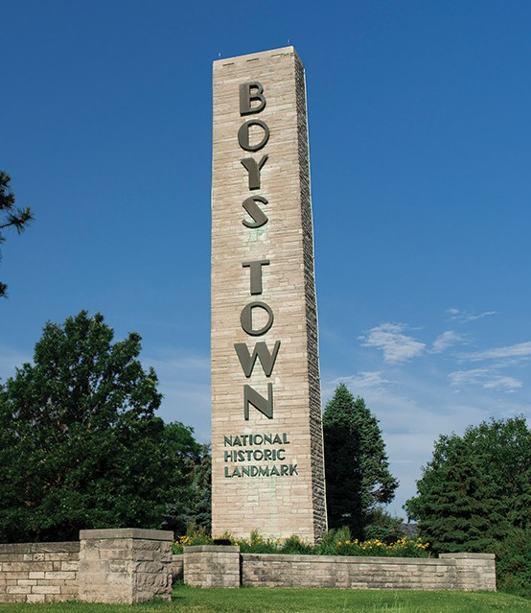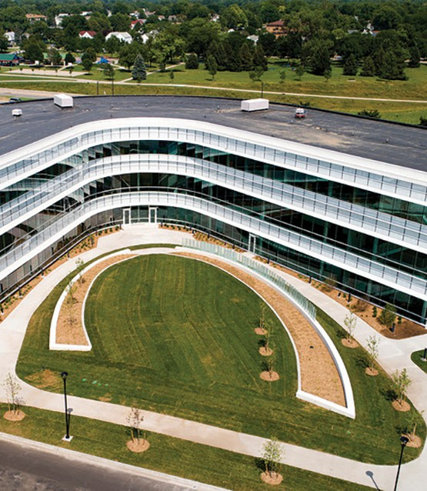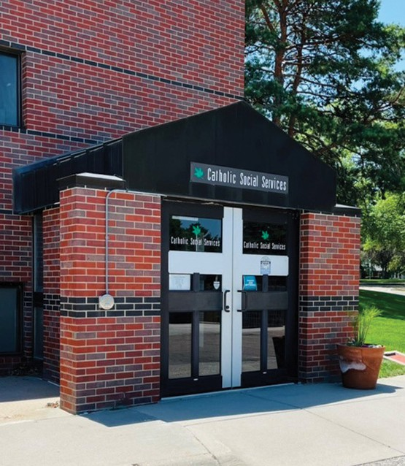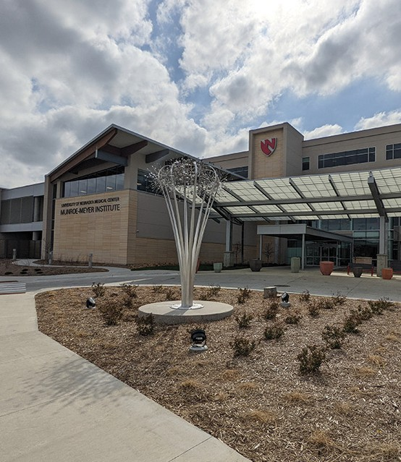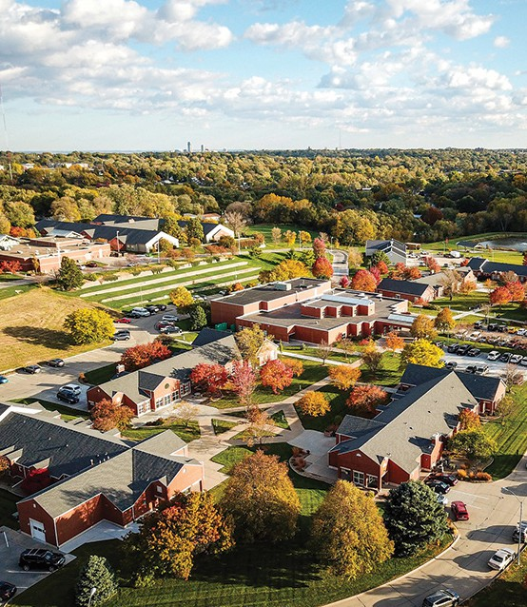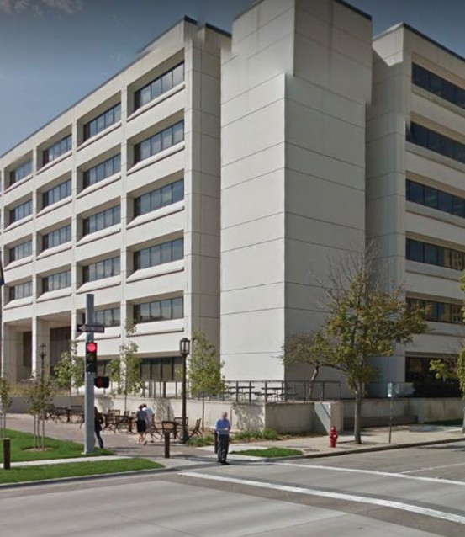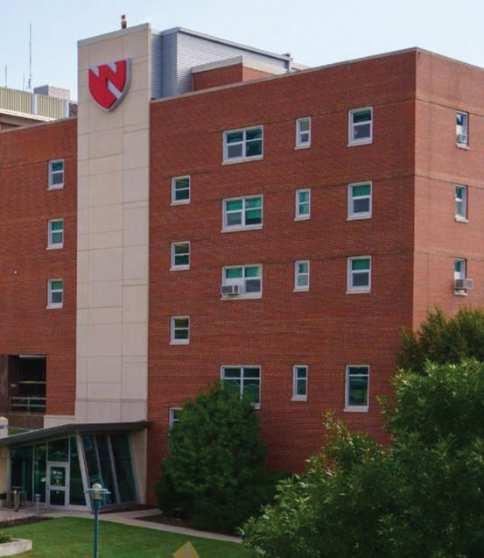

* Children & Adolescents
* Primary Care
* Empirically Supported Treatments
* Individual, Family, and Group Therapy
* Consultation - Schools and Programs

# Immaculate Heart of Mary Counseling Center

* Psychological and Psychospiritual Assessment
* Children, Adolescents, and Adults
* Individual, Couples, Family, Group
* Faith-Integrated Therapy
* Trauma Informed, Evidence-Based Practice
* Professional Consultation and Training Workshops

# Counseling and Psychology Services

* University Counseling Center
* Undergraduate and Graduate Students
* Individual, Relational, and Group Therapy
* Crisis Intervention/Risk Assessment
* Concentration in Specialized Area
* Outreach and Consultation
* Diversity, Equity and Inclusion Experience

# Munroe-Meyer Institute

* Children and Adolescents
* Integrated Primary Care and Rural Integrated Care
* Developmental Disabilities
* Brief Individual, Family and Group Therapy
* Research
* Empirically Supported Treatments
* Applied Behavior Analysis
* Assessment and Treatment of Severe Challenging Behaviors
* Autism Diagnosis

# Nebraska Department of Health and Human Services

* Adults
* Assessments
* Applied Behavior Analysis
* ICF-ID/DD and Community Providers
* Interdisciplinary Teams

# Nebraska Medicine Psychology Department

* Tertiary Care Medical Center
* Children, Adolescents, Adults, Older Adults
* Psychiatric Disorders
* Coping with Acute/Chronic Medical Illnesses
* Assessment, Individual Therapy
* Consultation/Liaison
* Evidence Based Practice

# Morningstar Counseling and Consultation

* Intertribal Behavioral Health
* K-12 Tribal Schools
* Tribal College
* Integrated Behavioral Health
* Individual and Group Therapy
* Outreach and Consultation
* Decolonized Supervision of Training

# QLI

* Private Nonprofit Post-Hospital Rehabilitation Center
* Adults
* Brain Injury, Spinal Cord Injury, Stroke
* Individual, Family, and Group Therapy
* Neuropsychological Assessment and Consultation